PHENIKAA UNIVERSITY
SCHOOL OF COMPUTING


COURSE MODULE: SOFTWARE ARCHITECTURE
PROJECT TITLE: BadNet - Badminton Social Network

Instructor: ThS. Vũ Quang Dũng
Group: Đinh Quang Lập (23010416)
Nguyễn Hoàng Thái Bảo (23010096)
Class: CSE703110-1-3-25(N01)

Ha Noi, June 17, 2026
Contents
Individual Report Note 3
Individual Responsibility 3
Chapter 1: Implementation and Coding 4
1.1 Development Environment and Tools 4
1.2 Project Directory Structure 4
1.3 Main Implemented Features 5
1.4 Simplified Workflow Descriptions 6
1.5 System Screenshots 8
Chapter 2: System Testing 12
2.1 Test Plan 12
2.2 Test Cases 13
2.3 Test Result Summary 14
Chapter 3: Deployment and User Guide 14
3.1 Deployment Scope 14
3.2 System Requirements 14
3.3 Environment Configuration 14
3.4 Installation and Run Instructions 15
3.5 Demo Accounts 15
3.6 Player User Guide 15
3.7 Admin User Guide 16
3.8 Deployment Limitations 16
Chapter 4: Conclusions and Future Work 16
4.1 Achievements 16
4.2 Limitations and Challenges 17
4.3 Lessons Learned 17
4.4 Future Work 17
4.5 Final Conclusion 18
References 18

Individual Report Note
This individual report is extracted from the group final project report for BadNet. It focuses on the sections assigned to this member: implementation and coding, system testing, deployment and user guide, and conclusions with future work. This report keeps the same technical context as the group project but only presents the work related to implementation, testing, deployment instructions, and final evaluation.

Individual Responsibility
Assigned Section | Responsibility
Implementation and Coding | Explain implemented modules, project directory structure, main features, and simplified service-level workflows.
System Testing | Document the test plan, requirement-linked test cases, and test results for player and admin workflows.
Deployment and User Guide | Provide local setup instructions, demo accounts, and user guidance for player and admin roles.
Conclusions and Future Work | Summarize achievements, limitations, lessons learned, and practical future improvements.

Chapter 1: Implementation and Coding

1.1 Development Environment and Tools
BadNet is implemented as a Laravel web application with a MySQL database, Blade templates, React components, vanilla CSS, and Vite asset bundling. The implementation follows a layered structure: routes receive requests, controllers validate and coordinate workflows, services contain business rules, models persist data, and views render the user interface.
Technology | Use in BadNet
PHP 8.1 and Laravel 9 | Backend routing, controllers, middleware, validation, Eloquent ORM, and Blade rendering.
MySQL | Stores users, posts, teams, tournaments, matches, bets, wallet transactions, and notifications.
Blade templates | Renders admin panel and many user-facing pages.
React and Vite | Adds interactive player portal components and modern frontend bundling.
Vanilla CSS | Controls theme tokens, light/dark mode, spacing, tables, cards, and admin layout.
PHPUnit / Laravel test runner | Supports automated regression tests for selected backend flows.

1.2 Project Directory Structure
src/
app/Http/Controllers/ Main user and admin controllers
app/Models/ Eloquent models for users, matches, teams, bets
app/Services/ Business logic such as betting and wallet updates
resources/views/ Blade templates
resources/react/ React player portal components
public/css/style.css Shared visual system and responsive styling
routes/web.php Named routes for user and admin pages
database/migrations/ Database table definitions
tests/Feature/ Feature tests

1.3 Main Implemented Features
Feature Area | Implementation Description
Authentication | Users register, verify email immediately after sign-up, log in, log out, and reset passwords with a 15-minute token.
Dashboard and Feed | The home dashboard shows social posts, match suggestions, player stats, notifications, and quick actions.
Challenges and Matches | Players can create challenges, accept or reject invitations, find opponents, and submit match results.
Teams and Tournaments | Users can join teams and tournaments while leaders and admins manage members or participants.
Betting and Wallet | A pool betting flow locks virtual points, shows odds, records wallet ledgers, and supports admin control.
Notification Center | Notifications are grouped by interaction, match, betting/wallet, and system categories with read, unread, pin, and deep-link actions.
Admin Panel | Admins can manage players, roles, wallet balances, betting markets, content moderation, statistics, and audit logs.

1.4 Simplified Workflow Descriptions
The real implementation contains Laravel code. The following simplified workflow descriptions explain the most important logic without copying long source files.
Bet placement and wallet locking:
placeBet(user, match, stake, selectedWinner):
verify match is open for betting
start database transaction
lock match and user wallet rows
if stake > wallet balance:
stop and show warning
create bet record
subtract stake from wallet
create wallet transaction: "stake locked"
send bet confirmation notification
commit transaction

Admin wallet adjustment:
adjustWallet(admin, targetUser, newBalance, reason):
check admin permission
lock target user balance
save old balance
update wallet to new balance
create wallet ledger row with actor, before, after, and reason
write audit record

Notification action handling:
updateNotification(notification, action):
if action is read:
set read_at time
if action is unread:
clear read_at time
if action is pin:
toggle pinned state
return updated unread counter

Team and tournament membership control:
manageMember(actor, group, user, action):
if actor is admin or group leader:
add or remove user
notify affected user
else:
deny request

1.5 System Screenshots
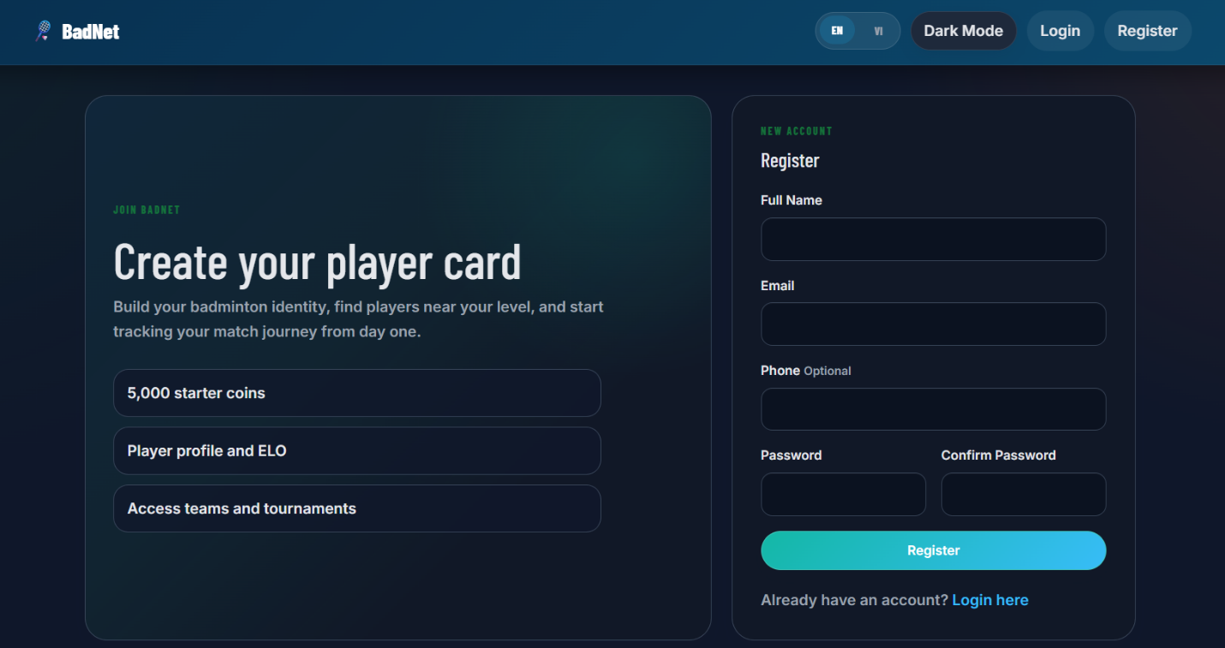
Figure 1.1. Registration screen for new player accounts.
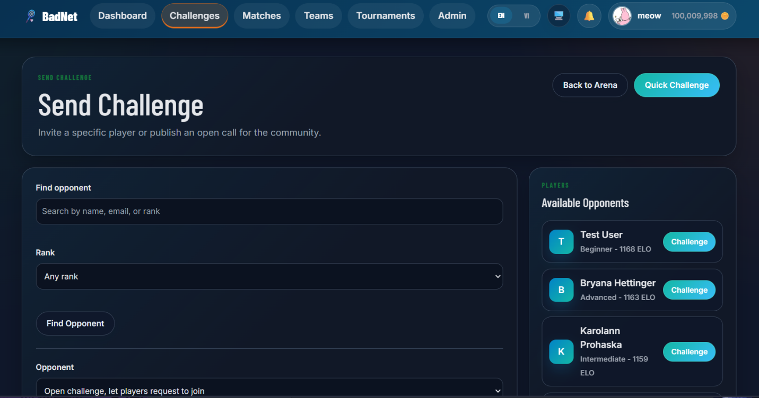
Figure 1.2. Challenge creation screen for finding an opponent.
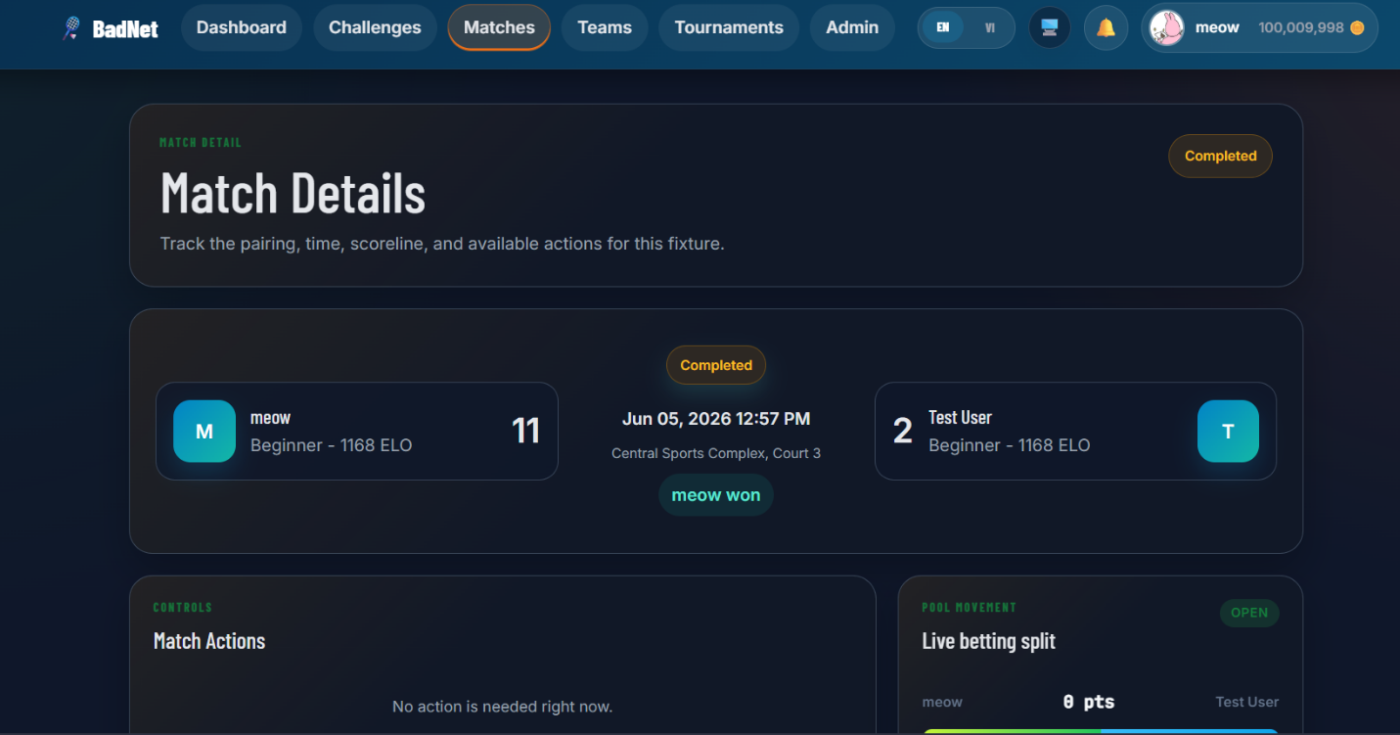
Figure 1.3. Match detail page with player and match information.
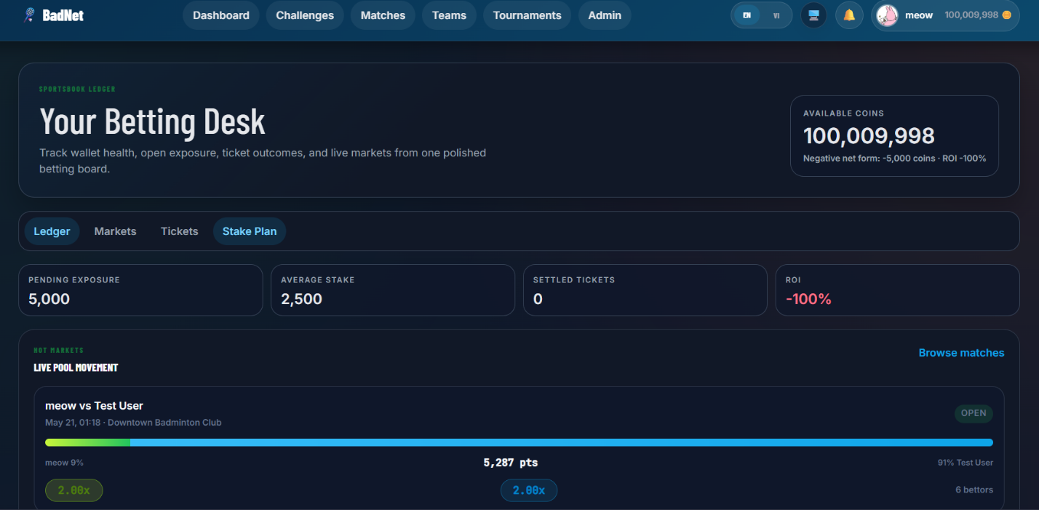
Figure 1.4. Betting desk showing wallet balance and live pool movement.
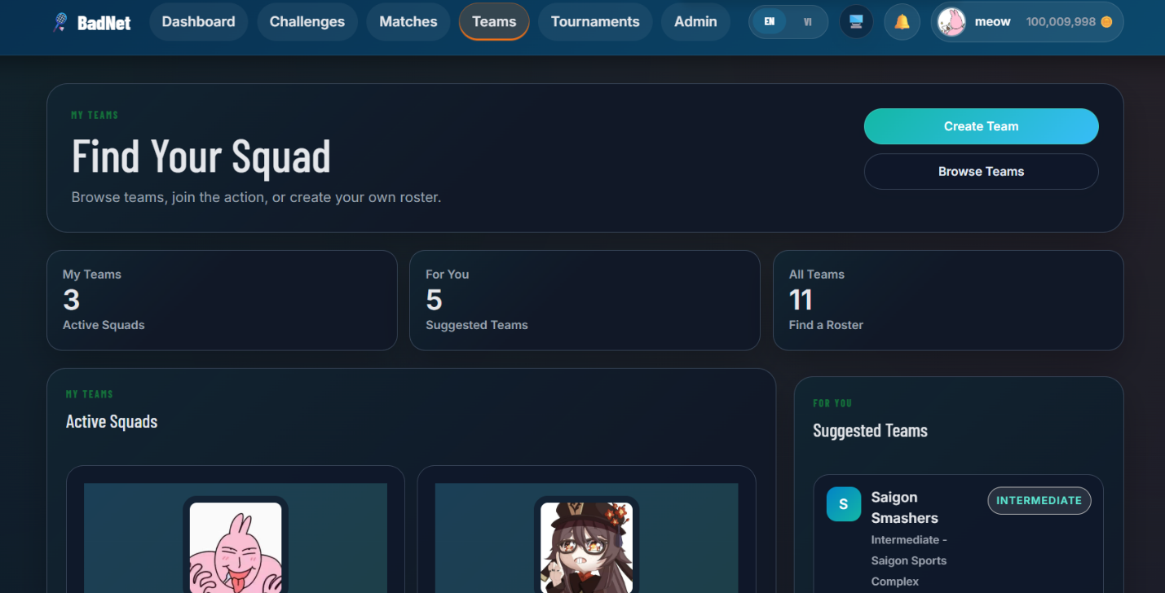
Figure 1.5. Team page with members and team activity.
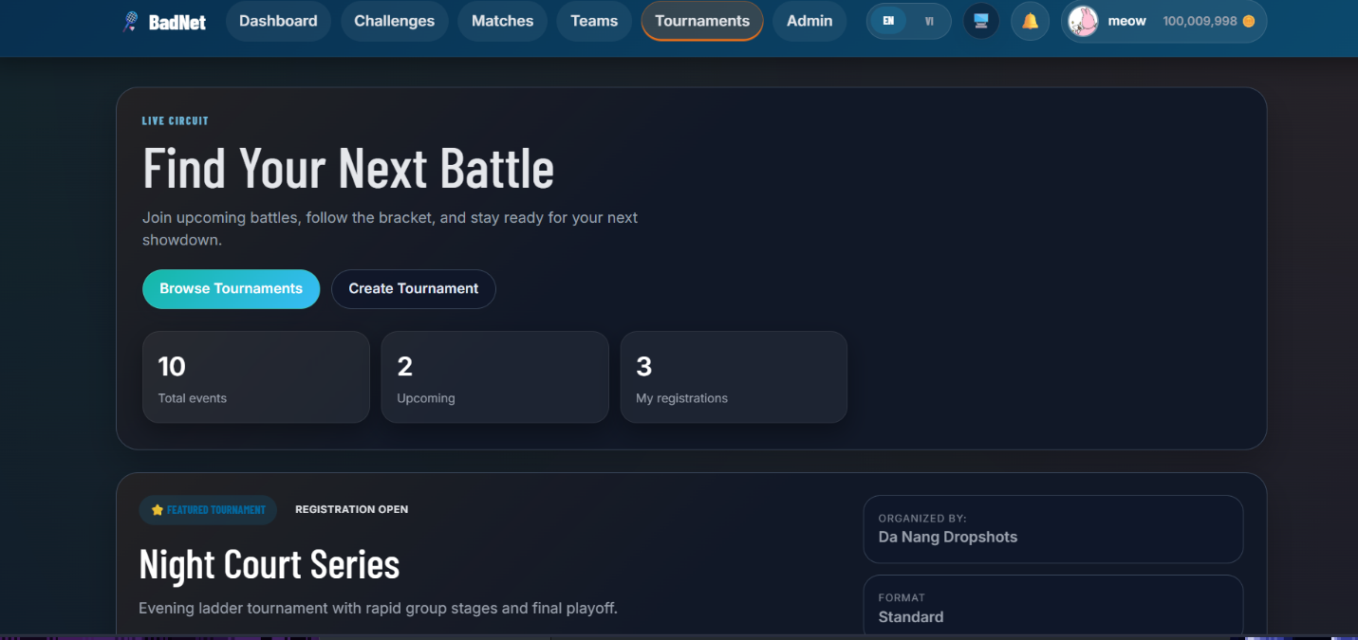
Figure 1.6. Tournament browsing and registration interface.
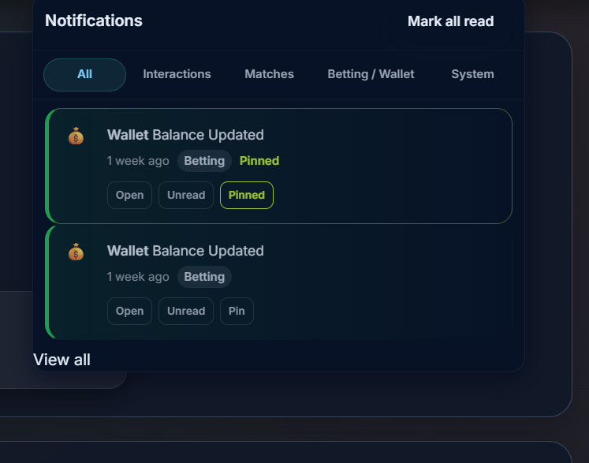
Figure 1.7. Notification center with categorized notification actions.
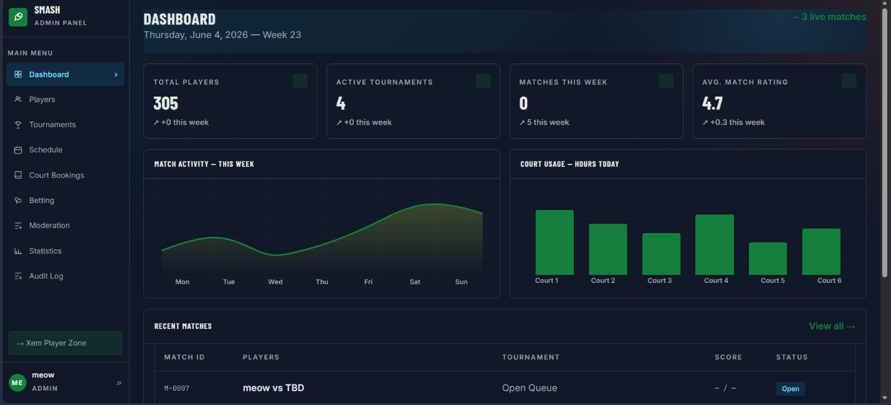
Figure 1.8. Admin dashboard with statistics, charts, and recent matches.

Chapter 2: System Testing

2.1 Test Plan
Testing was organized around major user workflows and high-risk admin/betting functions. Manual browser testing validates the UI flows, while automated Laravel tests are used for selected backend integrity checks. The most important areas are authentication, social feed, challenge and match workflows, team and tournament membership, betting, wallet ledgers, notifications, and admin control.
Test Area | Goal
Authentication | Confirm registration, verification, login, and password reset behavior.
Social Feed | Confirm posts, likes, comments, and delete actions.
Challenges and Matches | Confirm creation, acceptance, rejection, result submission, and disputes.
Teams and Tournaments | Confirm join, detail display, and member or participant management.
Betting and Wallet | Confirm stake validation, wallet deduction, refund, and odds control.
Notifications | Confirm unread dot, mark all read, unread, pin, and deep-link behavior.
Admin Panel | Confirm player role and wallet edits, moderation, and charts.
Theme and UI | Confirm light and dark mode readability.

2.2 Test Cases
ID | Req. | Scenario | Expected Result | Status
TC-001 | FR-01 | Register with valid credentials | Verification page is shown | Passed
TC-002 | FR-01 | Submit invalid verification code | Code is rejected | Passed
TC-003 | FR-01 | Resend verification code | New code is delivered | Passed
TC-004 | FR-01 | Request password reset email | 15-minute token message appears | Passed
TC-005 | FR-01 | Reset password using valid token | New password works | Passed
TC-006 | FR-02 | Create feed post | Post appears in feed | Passed
TC-007 | FR-02 | Like and unlike post | Like count updates | Passed
TC-008 | FR-02 | Comment on post | Comment is displayed | Passed
TC-009 | FR-02 | Delete own post | Post is removed | Passed
TC-010 | FR-03 | Create quick challenge | Challenge is saved | Passed
TC-011 | FR-03 | Accept challenge | Match is created | Passed
TC-012 | FR-03 | Reject challenge | Challenge becomes rejected | Passed
TC-013 | FR-03 | Create open match | Match appears in list | Passed
TC-014 | FR-03 | Submit and confirm result | Match is completed | Passed
TC-015 | FR-03 | Dispute result | Admin moderation is required | Passed
TC-016 | FR-04 | Join database team | User appears in members | Passed
TC-017 | FR-05 | Leader adds member | Member is inserted | Passed
TC-018 | FR-05 | Leader removes member | Member is removed | Passed
TC-019 | FR-06 | Open tournament detail | Detail page loads | Passed
TC-020 | FR-06 | Join open tournament | Participant is added | Passed
TC-021 | FR-07 | Admin adds participant | Participant appears | Passed
TC-022 | FR-07 | Admin removes participant | Participant is removed | Passed
TC-023 | FR-08 | Open betting slip | Odds and wallet are shown | Passed
TC-024 | FR-08 | Stake exceeds wallet | Confirm is disabled | Passed
TC-025 | FR-09 | Confirm valid bet | Stake is locked | Passed
TC-026 | FR-09 | Cancel betting market | Stake is refunded | Passed
TC-027 | FR-10 | Admin updates odds | Odds are saved | Passed
TC-028 | FR-10 | Admin suspends market | Betting closes | Passed
TC-029 | FR-11 | Admin bans user | User is blocked | Passed
TC-030 | FR-11 | Admin restores user | User regains access | Passed
TC-031 | FR-11 | Admin changes role | Admin rights are applied | Passed
TC-032 | FR-12 | Admin adjusts wallet | Ledger records adjustment | Passed
TC-033 | FR-13 | Mark all notifications read | Unread dot disappears | Passed
TC-034 | FR-13 | Mark notification unread | Counter updates | Passed
TC-035 | FR-13 | Pin notification | Pinned item stays on top | Passed
TC-036 | FR-13 | Open notification link | Target content opens | Passed
TC-037 | FR-14 | Hover dashboard chart | Tooltip shows value | Passed
TC-038 | FR-14 | Hover statistics chart | Nearest value appears | Passed
TC-039 | FR-15 | Use light dashboard | Text remains readable | Passed
TC-040 | FR-15 | Use light admin players | Inputs and tables remain readable | Passed

2.3 Test Result Summary
Metric | Value
Total documented test cases | 40
Passed | 40
Failed | 0
Blocked | 0
Not executed | 0
Coverage note | The tests cover the main player-facing and admin-facing workflows for the academic demo.

Chapter 3: Deployment and User Guide

3.1 Deployment Scope
BadNet was prepared for local demonstration and report evaluation. The system can be installed and run on a developer machine using Laravel, MySQL, and Node.js. It has not been deployed to a public server, so features such as HTTPS, domain configuration, queue workers, WebSocket scaling, centralized logging, and automatic backup are outside the current scope.

3.2 System Requirements
Requirement | Recommended Version
PHP | 8.1 or newer
Composer | Latest stable
Node.js and npm | Node 18 or newer
Database | MySQL 8 or compatible MariaDB
Browser | Microsoft Edge or Chrome

3.3 Environment Configuration
Before running the project, the developer should copy `.env.example` to `.env`. The main values to configure are `APP_URL`, database name, database username, database password, and mail settings. Mail configuration is required when email verification or password reset is used during the demonstration.

3.4 Installation and Run Instructions
Command | Purpose
cd src | Move into the Laravel application directory.
composer install | Install PHP dependencies.
npm install | Install frontend dependencies.
copy .env.example .env | Create a local environment configuration file.
php artisan key:generate | Generate the Laravel application key.
php artisan migrate --seed | Create database tables and seed demo data.
npm run build | Build frontend assets for the browser.
php artisan serve | Start the local Laravel development server.

3.5 Demo Accounts
Role | Email | Password | Purpose
Admin | admin@example.com | password | Access admin panel, manage users, wallet, betting markets, and statistics.
Player | testuser@example.com | password | Test dashboard, matches, teams, tournaments, notifications, and betting.
Player | hunter_rain@hotmail.com | configured locally | Development/demo account used during implementation and verification.

3.6 Player User Guide
1. Register a new account or log in with a demo player account.
2. Open the dashboard to view community activity, posts, match suggestions, and player information.
3. Create a challenge by opening the Challenges page, finding an opponent, selecting match details, and sending the challenge.
4. View match details from the Matches page or notification links. After a match, submit or confirm the match result.
5. Place a virtual-point bet by opening the Betting Desk or a match detail page, choosing a winner, entering a stake, checking wallet warnings, and confirming the bet.
6. Browse or join teams and tournaments from their navigation pages.
7. Use the notification center to mark items read or unread, pin important notifications, and open related content.

3.7 Admin User Guide
1. Log in with an admin account and open the admin dashboard.
2. View system statistics, charts, recent matches, and operational summaries.
3. Manage players by updating roles, banning or restoring accounts, and adjusting wallet balances when needed.
4. Manage betting markets by updating odds, approving markets, suspending betting, or cancelling markets.
5. Manage tournaments, schedules, moderation tasks, and audit logs from the admin sidebar.
6. Admin functions are protected by authentication and admin authorization, so normal player accounts cannot access these actions.

3.8 Deployment Limitations
The current deployment is suitable for local demonstration and report evaluation. It does not include a public domain, HTTPS, production queue workers, a production WebSocket server, centralized logs, external monitoring, or real payment integrations.

Chapter 4: Conclusions and Future Work

4.1 Achievements
Achievement | Description | Evidence
Authentication and player access | Users can register, verify email, log in, and reset passwords. | Registration/login screens and authentication routes.
Challenge and match workflow | Players can create challenges, join matches, and manage match results. | Challenge and match detail screenshots.
Team and tournament features | Users can browse and join teams or tournaments. | Teams and tournaments screenshots.
Betting and wallet workflow | Virtual-point bets are placed through betting pages and wallet records. | Betting desk screenshot and wallet test cases.
Notification center | Notifications support categories, read/unread, pin, and deep links. | Notification center screenshot.
Admin operations | Admins can manage users, wallets, betting markets, statistics, and moderation. | Admin dashboard screenshot.
Testing evidence | The individual report documents 40 passed test cases. | System testing chapter and test report.

4.2 Limitations and Challenges
The current version is suitable for an academic demo, but it still has several limitations. The betting feature uses virtual points only, so it does not handle real payments or payment-provider errors. The deployment is also limited to a local environment; therefore, server configuration, HTTPS, monitoring, backup, and production WebSocket setup have not been tested. In addition, most UI checks were performed manually, and the system does not yet include advanced anti-fraud rules for betting behavior.

4.3 Lessons Learned
During implementation, the betting and wallet features showed why business logic should not be placed directly in views or routes. Wallet updates, stake locking, refunds, and admin adjustments need to follow a clear service-level workflow so that balances remain consistent. The admin features also showed that sensitive actions such as role changes, wallet edits, and betting market updates should be protected and recorded. From the reporting side, screenshots and test cases helped make the implemented features easier to verify during demo preparation.

4.4 Future Work
Future Improvement | Priority | Expected Benefit
Production WebSocket setup | High | Provide instant notification and betting pool updates.
Queue worker and background jobs | High | Process email, notifications, and settlement tasks reliably.
Advanced risk checks | Medium | Detect suspicious betting behavior and protect wallet integrity.
Court provider integration | Medium | Support real court availability and booking confirmation.
Tournament bracket automation | Medium | Generate rounds, brackets, and standings automatically.
Mobile PWA support | Medium | Improve mobile access and push notifications.
Admin export reports | Low | Support financial, moderation, and tournament reporting.
Automated browser testing | High | Reduce manual UI regression effort.
Production monitoring | High | Track errors, performance, and system health.

4.5 Final Conclusion
BadNet meets the main goals of the academic project by providing a working badminton social network with player accounts, challenges, matches, teams, tournaments, virtual betting, wallet tracking, notifications, and admin management. The system is not production-ready yet, but it is complete enough for demonstration and evaluation. The next development stage should focus on real-time infrastructure, stronger security checks, production deployment, and more automated support for tournament organization.

References
[1] Laravel, Laravel Documentation, https://laravel.com/docs, accessed Jun. 17, 2026.
[2] PHP Group, PHP Manual, https://www.php.net/manual, accessed Jun. 17, 2026.
[3] Oracle, MySQL 8.0 Reference Manual, https://dev.mysql.com/doc, accessed Jun. 17, 2026.
[4] React Team, React Documentation, https://react.dev, accessed Jun. 17, 2026.
[5] Vite Team, Vite Guide, https://vite.dev/guide, accessed Jun. 17, 2026.
[6] OWASP Foundation, OWASP Top Ten, https://owasp.org, accessed Jun. 17, 2026.
[7] Chart.js Contributors, Chart.js Documentation, https://www.chartjs.org/docs, accessed Jun. 17, 2026.
[8] L. Bass, P. Clements, and R. Kazman, Software Architecture in Practice, 4th ed., Addison-Wesley, 2021.

